CURRICULUM VITAE

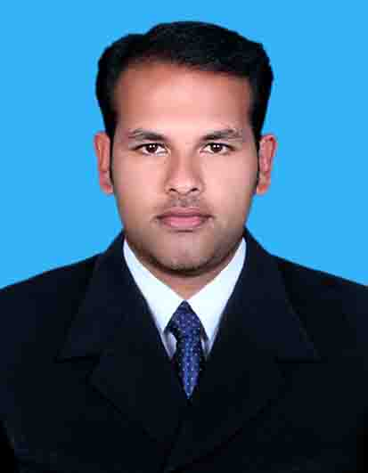
KIRAN PORINCHU C
CHOONDAL(H)
CHOONDAL(PO)
THRISSUR(DIST)
KERALA
PIN-680502
e-mail :kiranchoondal@gmail.com
Ph :0501315494

OCCUPATIONAL OBJECTIVE

To achieve organizational excellence with drive, initiative and commitment and to come up in life as a talented nursing professional in a reputed organization providing excellent growth opportunities and a challenging work environment.
WORK EXPERIENCE

Total Work Experience : 4 year 2 months

Positions Held
Registered Nurse ( Dodsal company clinic TARIFF)
Staff Nurse (medical ICU)
Staff nurse (cardiac intensive care unit)
HAAD LISENCE DETAILS
Name- Kiran Porinju Choondal
Lisence number – GN16518
Lisence as- Registered Nurse
Issue Date- 04/2012
Expiry Date-04/2014
PROFESSIONAL REGISTRATION

Kerala Nurses and midwives Council Registration
Registered nurse no : 44970
Registered midwife no : 45820
Registration Date : 21.11.2008
EDUCATIONAL QUALIFICATION

Course | Board/University | Year
B.Sc Nursing | University of Calicut,kerala | 2003-2008
H.S.E | Board of Higher Secondary Education, Kerala | 2001-2003
S.S.L.C | Board of Public Examinations, Kerala | 2001

PROFESSIONAL QUALIFICATION

B.sc nursing (graduate)

Recognized by Indian nursing council, Kerala nursing council and affiliated to university of Calicut

Institution : Al Shifa College of nursing, perinthalmanna

Year : 2003-2008

ADDITIONAL QUALIFICATION

- HAAD-RN passed
- BLS/ACLS Certified

PERSONAL PROFILE

Father’s Name : C M Porinchu

Date of Birth : 19/02/1986

Sex : Male

Religion : Christian/RC

Nationality : Indian

Marital Status : Single

PASSPORT DETAILS
Number : F 1978009

Date of Issue : 14/02/2005

Date of Expiry : 13/02/2015

EMPLOYMENT DETAILS IN BRIEF
Current Employer
Name of the employer : Dodsal Engineering And Constructions ,
TARIFF CLINIC License NO:MF 2498
Position : Registered Nurse
Duration : 26/02/2012 to till date

Previous employer 1 : Al shifa hospital
Ooty road, perinthalmanna
Malappuram (dist)
Kerala
PIN:679 322
Duration of employment : 27/11/2008 TO 28/11/2009
Department : Intensive coronary care unit
Position held : staff nurse
Capacity of Hospital : 450 Bedded
Previous Employer 2 : BLK Memorial Hospital
New delhi
Duration of employment : 30/12/2009 TO 02/05/2011
Department : medical intensive care unit
Position held : staff nurse
No. of Bed in the unit : 10 bedded
REFERENCE

1 Mr Thejus R Shah
HR Manager
Dodsal Enginering and Constructions
Abudhabi-
Ph no- 0505596103

2 .Mrs.June Caroline
Head of the Nursing department
B.L.K.Memorial Hospital..
New Delhi.
Tel :011-25752885

DECLARATION

I hereby declare that all the particulars given above are trace to the best of my knowledge and I shall produce all the original documents at the time of interview.

Place: Choondal Yours faithfully
Date: 00/06/2012 KIRAN PORINCHU

