SARAVANAN.T
Email:fpsaravanan@yahoo.com 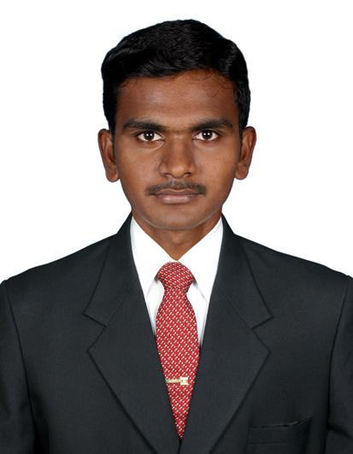
Voice: +91-9020502096

Career Objective:
Seeking a challenging environment that encourages continuous learning and creative exposure to new ideas that stimulates professional and personal growth.

Professional Summary:
- Having best creativity and innovative thinking.
- Having good communication skills, dedication, hard-working and leading activities.

Education Qualification:
- Completed B.Sc, in Hotel management & catering science with distinction from valluvar college of science and management karur.
- Completed DCA in Diploma in computer application from EVARONN Institute.
- Higher Secondary State Board (2004 – 2005) with 80%.

CO-Curricular Activities:
    - I participated National Level chef competition organized by HERA and VLB college coimbatore .
    - Take Part in National Level seminar on How to Became a Successful Hotelier Organized by Hospitality Educators & Recruiter’s Association.
- I won Best Student Award in food production department’07.
- A member of South Indian Culinary Association.

Area of Interest:
- Food & Beverage production (continental & gardemanager).

Training:
- Undergone Industrial Exposure Training at Hotel SULIVAN COURT(WELCOM GROUP), OOTY for a period of 3 months.
- Undergone Industrial Exposure Training at Hotel SANGAM, MADURAI for a period of 3 months.

Work Experience:

- Working with CLUB MAHINDRA LAKE VIEW RESORT, MUNNAR for one Year (jul08) as a HOT. I am working as a DCDP from jul’2009 to till the date.

Technical Qualification:
- Fruit & Vegetable carving
- Innavoting the salads

Computer knowledge:
- MS Office
- Visual basic
- C language

Personal Profile:
Name : saravanan.t
Father's Name : Mr. THANGAVEL.P
Mother’s Name : Mrs. RAJESHWARI
D.O.B : 18.05.1987
Gender : Male
Nationality : Indian
Languages known : English, Hindi, Tamil and malayalam
Hobbies : Playing table tennis and kabbadi.
Address : kavali palayam,
Kambaliam patti(po),
Sangarandam palayam(via),
Kangeyam(tk),
Thirupur (dt)
Pin: 638 706.
Residence Mobile : +91-9003383919

Declaration:
I hereby declare that the above-furnished particulars are true to the best of my knowledge & belief.

Place: Munnar SARAVANAN.T

