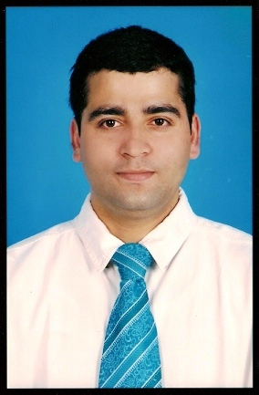
KRISHNA PRASAD REGMI

Shaqab Abela Catering Services Co. W.L.L.

Post box no. 14156 Doha, Qatar.

Mobile No: +974-33587268

Email: krishlike@yahoo.com

Objective:

Chef for a high class establishment where my experience and culinary specialties will be utilized in preparing a wide range of international cuisines.

Professional Experience:

Working in Pastry Kitchen: Since November 2011 (Temporary)

Qatar National Convention Center,

Member of Qatar Foundation,

Doha , Qatar.

Working in pastry kitchen: Since 23rd November 2005.

As a Pastry Man

Under Shaqab Abela Catering Services Co.W.L.L.

Doha, Qatar.

Worked for the following Multinational Projects in Ras Lafan Industrial Area, Qatar:

Technip Chiyoda join venture ( TCJV ) - 5 months.

JGC-KBR Middle East – 25th March 2010 to 19th May 2011.

CTJV-QCS – 30th June 2009 to 31st March 2010.

CTJV-QGX – 23rd Feb. 2006 to 30th june 2009.l

Professional Awards and Certificates:

- Hazard Identification CBT course certified by Pearl Village Training Centre, Ras Laffan—Qatar issued on 16th April 2011
- Foundation Certificate in Food Safety by British Safety Standards World issued on 15th August 2006
- Fire safety and Fire prevention Training certificate from Shaqab Abela Catering Services Co. issued on 12th May 2007.
- Chemical Handling training course(PPE and proper application of chemical) conducted in Ras Laffan Industrial City – Doha, Qatar 24th November 2007
- Certificate of Appreciation by Chiyodha Technip Joint Venture—QGX, Qatar dated 05th October 2008
- Confined Space Entry CBT course certified by Pearl Village Training Centre, Ras Laffan—Qatar, issued on 17th April 2011
- Hand and manual handling CBT course certified by Pearl Village Training Centre, Ras Laffan—Qatar issued on 16th April 2011
- House Awareness Training on Food safety held on 10th November 2009 at Shaqab Abela Catering Services Co.
- Certificate of Appreciation Pearl GTL project—Qatar Shell GTL, Qatar dated 18th April 2011
- Safety Excellence certificate issued by Qatar GAS II LNG onshore facilities project 2006

Educational Qualification: High School Certificate.

Personal Information:

Nationality | : | Nepal
Date of Birth | : | 04-03-1982
Sex | : | Male
Passport No | : | 2614910
Expiry date | : | 03-07-2015
Permanent address | : | Chit wan Nepal.
Languages Known | : | English, Hindi, Arabic.

Declaration:

I hereby declare that the above furnished details are true and correct to the best of my knowledge and belief.

