Usman Rasheed |  | 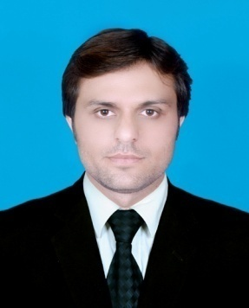
Chak # 68 R.B Tehsil Jaranwala, Distt. Faisalabad, 37630, Punjab, Pakistan. | Date of Birth: April 14, 1990  NIC No: 33104-9969603-1  E-Mail: usman.comsian@yahoo.com  Cell: (0092-333-9927868)  (00923336559568)

Objective
To become an integral part of an organization that can broaden my horizon of technical knowledge and where I can gain expertise in my work field.

Education
2008-2012 | BS Chemical Engineering (BS ChE)  COMSATS University of Science & Technology, Lahore, Pakistan. | 2.69/4.00
2005-2007 | Intermediate pre-Engineering (F.Sc)  Govt. College of Science Faisalabad, Pakistan | 729/1100

Final Year Project
Production of carbon dioxide from fuel oil.
According to this process fuel oil is combust in furnace, and carbon dioxide gas is separated from flue gases using absorption technique.

Areas of Interest
- Oil and gas production and processing.
- Polymer and rubber technology.
- Petroleum Industry.

Work Experience/Internships
SITARA Chemical Industries, Faisalabad, Pakistan (Jul 2011-Aug 2011)
Internee
I have completed four weeks internship in SCIL factory. I have worked on sodium hydroxide (NaOH ) and hydrochloric acid(HCL) production plant.
Masood Textile Mills LTD Faisalabad, Pakistan (Summer 2010)
Internee
Worked as internee for duration of 4 weeks in processing lab.

Computer Skills

- Microsoft Office Including Visio
- Corel Graphic Suite
- Adobe Photoshop

- AutoCAD
- C++
Operating Systems:
- MS Windows (98, 2000, XP, Vista, Windows 7)

Educational Visits
- NIMIR Chemicals Sheikhupura Pakistan
- DH Chemical sheikhupura Pakistan

Extra Curricular Activities
- Member of Al Adeeb Debating Society.
- Member of university blood donor society
- Participated in Debate Competitions.
- Arranged multiple events and recreational trips.

References
Reference will be furnished on demand.

