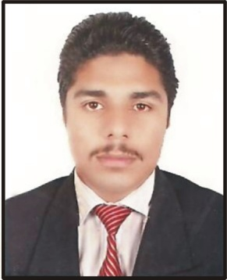
CURRICULAM VITAE
Syed Asad Uzair
Mob : +971 (55) 7337193
E-Mail: kingshah_s786@yahoo.com
Nationality: Pakistani
-------------------------------------------------------------------------------------------------------- ----------------------------------
OBJECTIVE
- To be associated with a progressive Institution which provide scope for utilizing the education and Skills to work on diverse and challenging tasks.
Technical Qualification
- 6 month Certificate of computer packages including office, Corel Draw, Adobe Photoshop, Print Artist, Ulead, hardware and internet.
- 1 year Experience of customer care office in MCB Bank in Peshawar(Pakistan).
- Holding a Valid U.A.E driving license since 2009( light vehicle )
Academic
- S.S.C (Secondary School Certificate) or Matriculation and F.S.C from board of intermediate and secondary Education Rawalpindi.

Personal Details
- Name Syed Asad Uzair
- Fathers Name Uzair Shah
- Nationality Pakistani
- Sex Male
- Marital status single
- Place of Birth Attock, Pakistan
- Date of birth 14 Sep,1990

Passport Details
- Passport No AA2894591
- Place of issue. Attock,Pakistan
- Visa status Employment Visa Valid till 2012
Languages
- English
- Arabic
- Urdu

