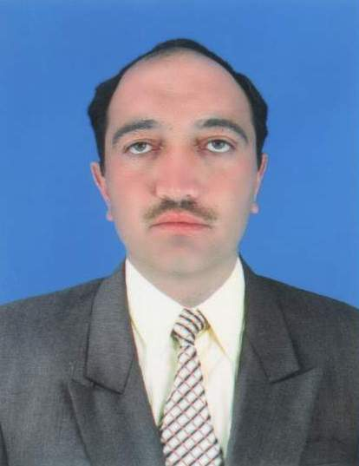
Rehmat Ullah
CURRICULUM VITEA

Personal Data  &  Contact Information | Father’s Name: Rasool Gul  Date of Birth : 19-04-1981  Nationality : Pakistani  Passport No. : DD 9153251  Issue Date : 02-02-2009 Exp Date : 02-02-2014  Marital Status : Married  Religion : Islam  Contact No. 055-1811440
Education &  Qualification | - S.S.C ----- Year 2000  B.I.S.E Peshawar Pakistan.  - F.A ------- Year 2009  Allama Iqbal Open University, Islamabad Pakistan.  - B.A ------- In Progress  Kohat University of Science & Technology, Kohat Pakistan.
Professional Qualification | - Diploma in Outside Plant & Cable Jointing.  Telecom Foundation Main power & Training, Islamabad Pakistan.  - Diploma in auto Cad ( 2D+3D ) Skill development council Peshawar Pakistan.
Computer Proficiency | - MS Windows  - Complete Office Automation  - Internet  - Auto CAD (2D + 3D)  - Adobe Photo Shop  - Hardware
Professional Experience | - 10 Years Driving Experience of LTV Vehicles. In Pakistan.  - 4 Years working experience in Auto Mobiles Sales.  - 2 Years working experience as a AutoCAD Draftsman and privet contractor.
Language | - English, Urdu and Pashto. Writing and speaking. And Arabic also speak little bit.
Visa status | Employment visa ( transferable )
Note | I have applied for UAE driving license.
Contact No. 055 1811440

