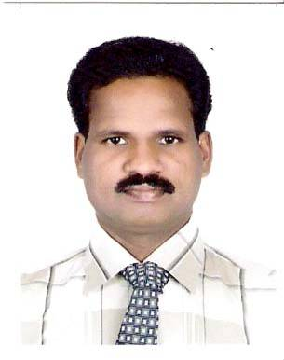

Resume of RAGHAVAN .K.K

Mobile: 050-1700735/055-7215019 E-mail : sindhuraghav@yahoo.com
______________________________________________________________________________

AREAS OF INTEREST : CATERING/REST. SUPERVISOR

CAREER OBJECTIVE
To pursue a long-term permanent and challenging career in hospitality industry, where my experience can be employed towards the growth of the organization.

SUMMERY OF QUALIFICATIONS
13 years years of professional experience in Gulf and India., willingness to do tasks beyond my responsibilities, ability to interact, skilled in handling people & and ability to work as a part of team and on my own initiative.

EMPLOYMENT HISTORY

Professional Experience in India

- Three months on the job training from “Hotel Ashok”(ITDC Managed Five Star Hotel) Bangalore ,as a Trainee Steward.
- One Year and five Months in “Hotel Lalittha Mahal”(New Name Elite Hotel, ITDC Managed Five Star Hotel) in Mysore worked as a Steward.
- Three year in Hotel “The Trident”(Managed by Obroi Hotels) in Ahamadabad as Captain.

Professional Experience in Gulf

- Five years in UN Iraq-Kuwait observation Mission (Managed By Damac Group) in Kuwait as a catering supervisor.
- One year in Eurest Support Service( ESS) as a feeding station supervisor for US marines in Kuwait.
- Two years in Al-Ammar catering Company as catering supervisor and camp in charge in Kuwait.

Nature of Work
- Managing the daily works of location.
- Responsible for the business performance of the unit.
- Planning sales ,Profitability and marketing plans.
- Preparing sales details and reports.
- Preparing suppliers updates.

(Cont..)

- Preparing duty charts for staff.
- Maintaining high standard hygienic measures ,quality control, health and safety of unit according to Hygienic department(HACCP).
- Conducting training programs and motivating staff.
- Responsible le for monthly Inventory and stocktaking.
- Responsible for achieving the sales targets and goals.
- Assisting the chef in menu planning and costing for food and accommodation for more than 300 staff people
- Day to day store keeping functions.
- Supervision of more than 1000 peoples food services.
- Extensive experience in different outlets like restaurant, coffee shop, bar ,banquets and room service.

EDUCATIONAL QUALIFICATIONS

Academic

PREE-DEGREE – from Calicut University, Kerala, India.

Professional

Food and Beverage Service Course - from Food Craft Institute and Extension
Center (Govt.of kerala),calicut ,kerala-India.

Professional Training - Basic food Hygiene (HACCP) training
conducted by German Medical Team.

COMPUTER SKILLS
MS Office (Word, Excel)
Internet Research Skills and knowledge of E-mail.

LANGUAGE SKILLS

English, Spanish, Arabic, Hindi , Tamil and Malayalam.

PERSONAL DATA

Date of Birth : 28th Dec 1970

Nationality : Indian

Marital Status : Married

Visa Status : Visit Visa

